TripleAction


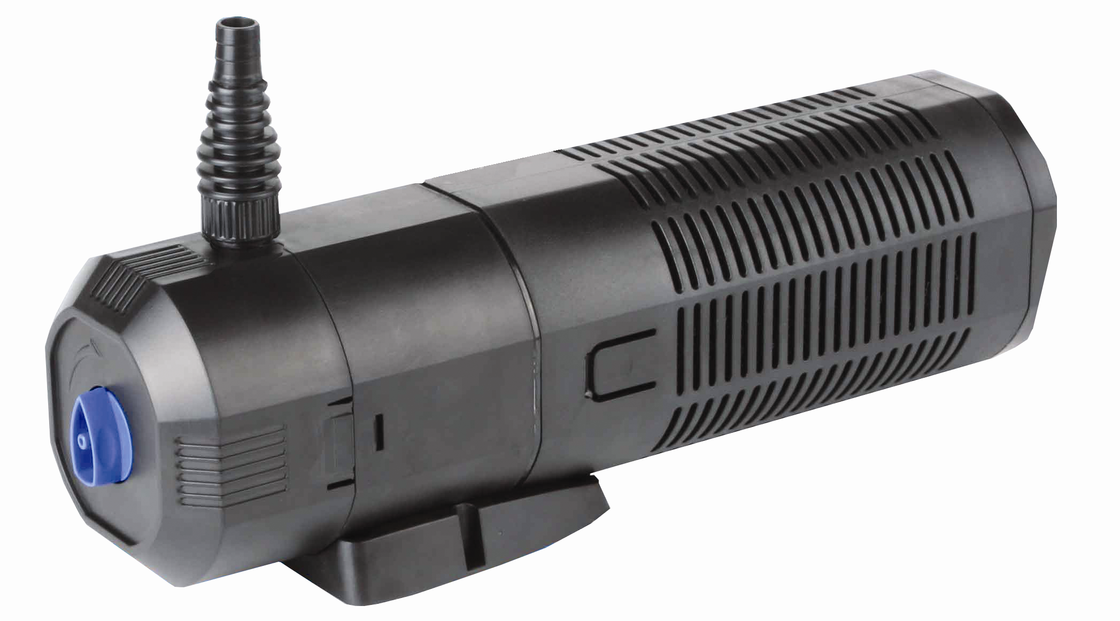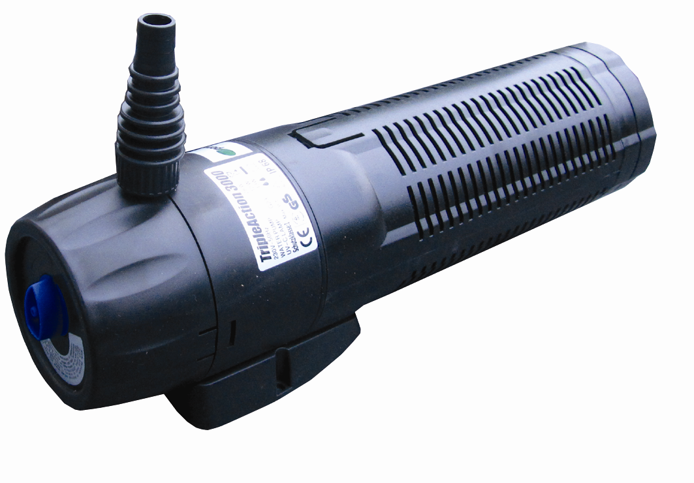

Submersible Pond Pump, Filter & UVC

Model | Power Rating | Max Flow lph | Max.  Head | Suitable for Max Pond Size | Outlet  Size mm | Dimensions  mm (wxl) | UVC  Watts
PXTP03000 | 28W | 1000 | 1.4m | 3000 Litres | 12/25 | 100 x 330 | 13
PXTP04000 | 45W | 2000 | 2.0m | 4000 Litres | 12/25 | 105 x 360 | 9
Comes complete with 5m electrical cable. Rated voltage 220-240V, 50Hz

Introduction
Congratulations on the purchase of your pondXpert combination unit. This unit is submersible and no additional filtration is required. By attaching 12-25mm hose the outlet can also power a waterfall or feature.
A fountain kit is available separately and is supplied free with certain models

Filtration is achieved in three ways:
- Foam situated inside the unit offers mechanical filtration by removing solids.
- Filter stones inside front chamber achieve biological filtration.
- UV forces microscopic green algae to clump together ready for collection.

Your unit must always be immersed in fresh water before it is switched on.
The UV is connected to a weatherproof transformer – this transformer can be left outside but it must not be submerged.
General safety Instructions
Read and observe all of the instructions clearly before installing, connecting and operating the unit. Make sure the pump is securely and correctly installed before switching on.
Always disconnect the unit when not in use and when carrying out maintenance.
Always disconnect all equipment in the pond before starting to handle, maintain, repair or install any pond equipment.
The appliance is not intended for use by persons (including children) with reduced physical, sensory or mental capabilities, or lack of experience and knowledge, unless they have been given supervision or instruction concerning use of the appliance by a person responsible for their safety. Children should be supervised to ensure that they do not play with the appliance. For safety reasons, servicing or repair of this item should only be carried out by pondXpert. Never hang or carry the pump by the power cord.
Do not operate the pump with a damaged cord or plug. The supply cord of the appliance cannot be replaced.
If the electrical cord is damaged the product should be scrapped.

Safety and Electrical Connections
This unit is designed for outdoor use only. It is waterproof and should be situated safely under the pond water. Ideally the pump should be situated at the bottom of the pond as this is where fish waste and debris collects. Take care to ensure that you can easily lift your pump out of the water for routine maintenance. If this is necessary do not pick your pump up by the electrical cable but by the main body/ cage of the pump.

Always disconnect all equipment in the pond before starting to handle, maintain, repair or install any pond equipment. Direct exposure to UVC light can damage the eyes and skin. NEVER look directly at the UV when switched on

The unit is electrically operated so great care must be taken during installation and operation. The following electrical and safety guidelines must be carefully followed.

Each unit has a pump that is supplied with a 5 metre length of 3 core electrical cable which is permanently connected to the pump.


The wires in the mains electrical lead are coloured in accordance with the
following code:
BLUE – Neutral (marked with an “N” in most terminal connections)
BROWN – LIVE (marked with an “L” in most terminal connections)
GREEN/YELLOW – EARTH (marked “E” or in most terminal connections)
1st January 2005 revised Building Regulations for England and Wales
Installing this product in the garden is classified as ‘notifiable’. The Regulations now require you to tell your local authority building control department that you intend to install this product before installation. Your local authority will let you know how you can get your installation approved

The termination to the mains supply should be permanent, inside a dry weatherproof enclosure, through a double pole switched fused spur with a minimum contact gap of 3mm – (disconnected) to BS 3676 – and fitted with a 3 or 5 amp fuse.
Exposed cable runs should be sensibly positioned, and protected if necessary by armoured conduit. A 10mA or 30mA Residual Current Circuit Breaker (RCD) MUST be fitted to the mains supply. Permanent installations to the mains supply (hard wiring) must comply with the regulations of the local electricity authority which may stipulate the use of metal or plastic conduit to protect the cable. If in any doubt about wiring to the mains supply contact a qualified electrician or your local electricity authority.

Directions for use

Installation
Place unit at bottom of pond – preferably on a level surface raised approx 10cm from floor (eg, upturned plant pot or clay brick) with outlet facing upwards.
Once installed the pond water will flow through the pump as the pump’s impellor draws in water. It is always best to position your pump at the opposite end to where the water returns to the pond to provide maximum circulation.
Your unit is supplied with a hosetail.. Pond hose size 12-25mm (1/2” to 1” ) can be attached to the inlet hosetail. Cut the inlet hose to the size appropriate to the size of hose you are using. Then connect the hose from your pump to your filter system or position it where you want the water to return. Ensure a watertight seal by the use of hoseclips.

Maintenance
Occasionally large solids may block the holes in the filter cage surrounding the pump – these should be carefully wiped away. A clogged or dirty intake will put a strain on the motor and greatly reduce its performance. If the area where the pump is stood is very dirty, raising its position slightly will assist flow. To clean the pump, remove the impellor housing and impellor. Use clean water and a small brush to remove debris (see below)

Changing the UV Bulb / Maintenance of the unit
A UV indicator around the body of the unit lights up to shown UV is working.
If it doesn’t light up, or if the bulb has been used for over 6 months you will need to change the UV bulb inside the unit.
To open the unit up, first disconnect from power supply and lift clear of water.
Remove backing plate with a cross head screwdriver then around the middle of the unit there are two push clips – hold these in then pull the main body apart. The foam is now accessible and can be cleaned if required. Access the impeller by again pressing the two clips around the top in and pulling the top case away from the main unit. Turn the impellor guard to gain access to the impellor and clean if required. The UV bulb can be accessed by unscrewing the screw located in the base of the remaining black casing. Turn the casing as indicated by the two arrows on the casing

Limited Warranty
This product is guaranteed for a period of 12 months (excluding rotor assembly) from the date of purchase for material or manufacturing defects. The guarantee covers the substitution of defective parts. However, the guarantee is considered null and void in the case of improper use, improper handling or negligence on the part of the buyer. If your pondXpert pump fails please take it back to the retail outlet from where it was purchased. You will be required to take your receipt/proof of purchase with you. This does not affect your statutory rights.
Your appliance contains valuable materials which can be recovered or recycled. Leave it at a local civic waste collection point.
PondXpert

A3 Bentley Avenue
Billingham
TS23 4BU
UK
01642 370898 www.pondxpert.co.uk

